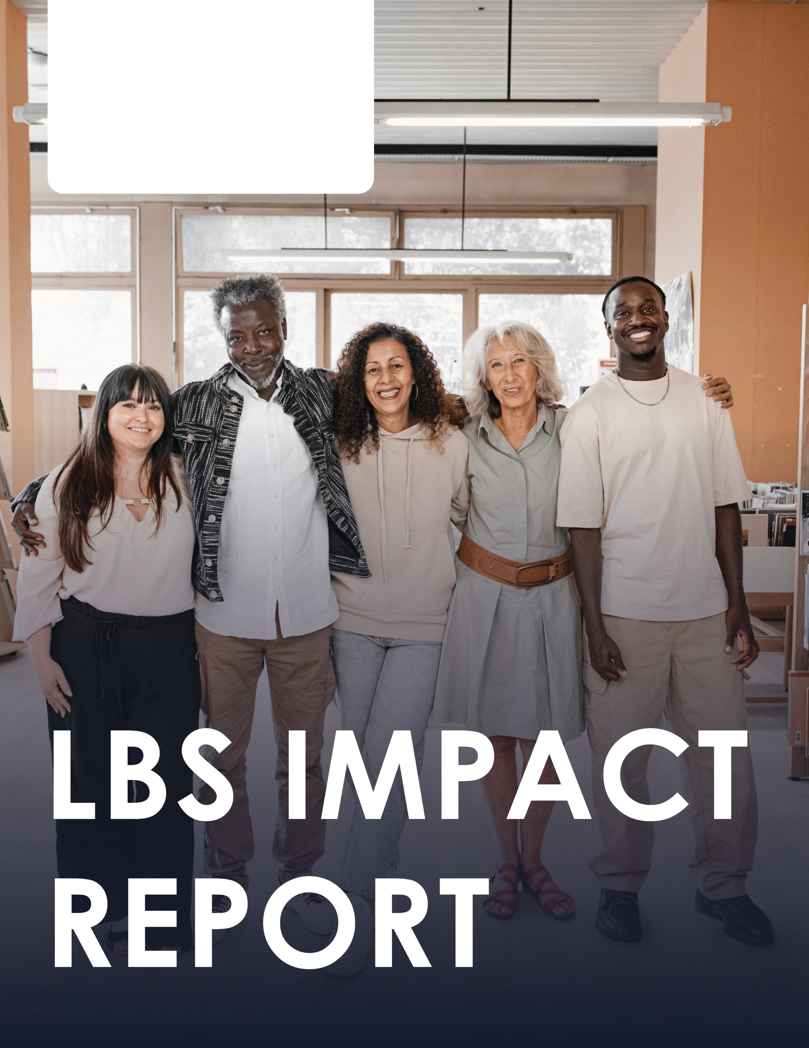

INSERT SCHOOL BOARD
NAME OR LOGO HERE

CONTENTS
WHAT IS LBS AND ITS IMPACT ON THE LEARNERS SERVED 3
OUR PROGRAM IN [INSERT NAME HERE] SCHOOL BOARD 4
LBS GUIDELINES, SCHOOL EFFECTIVENESS FRAMEWORK & GROWING SUCCESS 5
LBS PATHWAY TO ADULT CREDIT 6
WHO WE SERVE 7
TRENDS IN OUR DATA 12
AREA OF FOCUS FOR THE 20__ / 20__ FISCAL YEAR 13

WHAT IS LBS AND ITS IMPACT ON THE LEARNERS SERVED

The Ontario Literacy and Basic Skills (LBS) program helps adults in Ontario to develop and apply communication, numeracy, interpersonal and digital skills to achieve their goals. The LBS program serves learners who have goals to successfully transition to employment, postsecondary, apprenticeship, secondary school, and increased independence. The program includes learners who may have a range of barriers to learning.¹

LEARNER IMPACT
Recent analysis of international adult skills data and key macroeconomic performance indicators (GDP per capita and labour productivity) shows that increasing the literacy skills in the workforce by an average of 1% would, over time, lead to a 3% increase in GDP, or $54 billion per year, every year, and a 5% increase in productivity. This research also shows that improving the skills of people at the lower end of the scale (Levels 1 and 2 on the five-level scale for literacy) will have more impact than improving the skills of people who are already at Level 3 or higher. As the people most at risk of losing their entire job to automation are the people employed in low-skilled jobs, upgrading their skills would have the added advantage of making them more employable in a new higher-skilled job.”²
_____________________________________________
- Ministry of Training, Colleges and Universities. (2020). Literacy Basic Skills: Service Provider Program Guidelines. https://www.tcu.gov.on.ca/eng/eopg/publications/lbs-service-provider-guidelines-2020-en.pdf.
- Lane, J., & Murray, T. S. (2018). Literacy Lost: Canada’s Basic Skills Shortfall. Canada West Foundation. https://cwf.ca/research/publications/report-literacy-lost-canadas-basic-skills-shortfall/.

OUR PROGRAM IN
[INSERT NAME HERE]
SCHOOL BOARD

[INSERT SUBHEADING]
[INSERT TEXT DESCRIPTION HERE]

LBS GUIDELINES, SCHOOL EFFECTIVENESS FRAMEWORK & GROWING SUCCESS
Adult Credit programs, within Continuing Education departments, is funded by the Ministry of Education and as such, are guided by the objectives of the School Effectiveness Framework¹ and Growing Success.² Literacy and Basic Skills Programs, funded by the Ministry of Labour, Immigration, Training and Skills Development, is supported by the LBS Service Provider Guidelines.³
Several common objectives and priorities can be found in these three documents:
- direction, priorities and program improvement support student achievement
- monitoring and feedback for continuous improvement
- business plans identify program strengths, areas of development and steps required for improvement
- equitable service for all, with a special emphasis on underrepresented groups
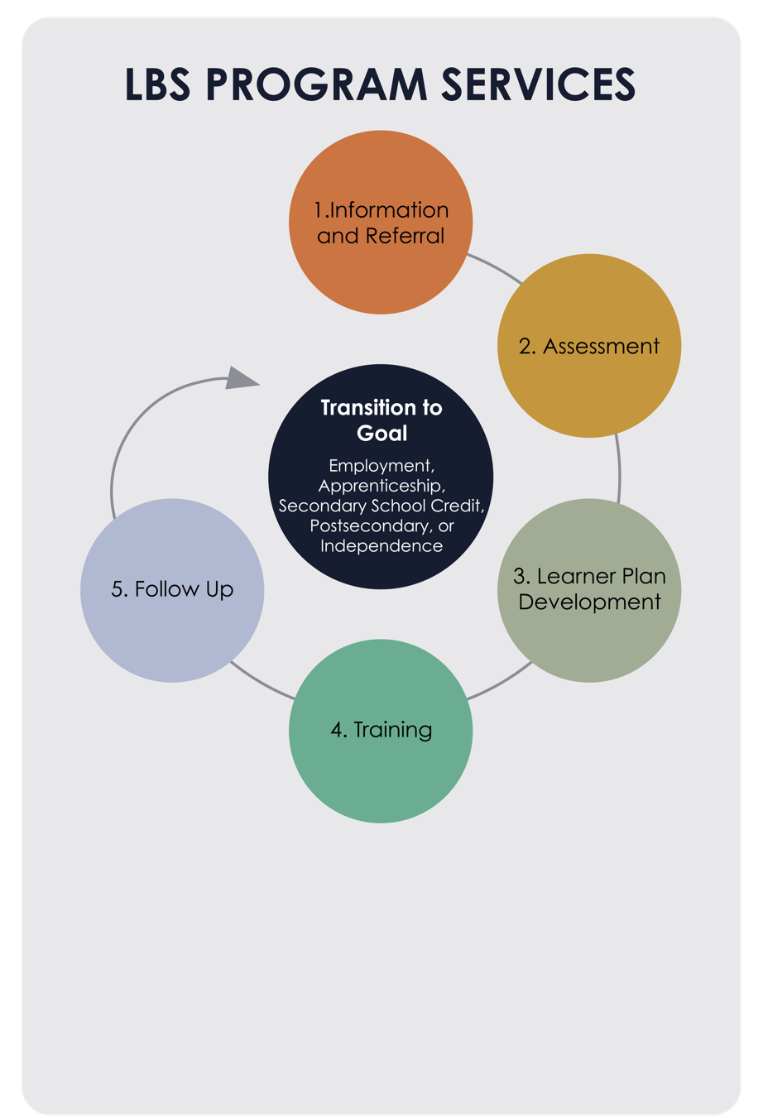
- procedures in relation to curriculum expectations connected to goals, learning styles and identified needs
- clear procedures on feedback
- administration of assessment over the length of training
- development of next steps for a student, in order to achieve their goal

RESOURCES
- Ontario Ministry of Education. (2023). School Effectiveness Framework: A support for school improvement and student success. https://files.ontario.ca/edu-school-effectiveness-framework-2013-en-2022-01-13.pdf.
- Ontario Ministry of Education. (2010). Growing success: Assessment, evaluation, and reporting in Ontario schools. (1st edition, covering grades 1 to 12). https://www.edu.gov.on.ca/eng/policyfunding/growsuccess.pdf.
- Ministry of Training, Colleges and Universities. (2020). Literacy Basic Skills: Service Provider Program Guidelines. https://www.tcu.gov.on.ca/eng/eopg/publications/lbs-service-provider-guidelines-2020-en.pdf.
05

LBS PATHWAY TO ADULT CREDIT

BRIEF FROM LBS SCAN REPORT
The purpose of this project was to determine the number of school board LBS programs offered in the province of Ontario, investigate the nature of the referral processes within their non-credit and credit programs, and examine how adult learners enrolled in LBS programs are supported in credit programs or assisted to transition into credit programs. The overarching purpose for this investigative focus was to highlight worthwhile practices for supporting adult learners to transition from LBS (non-credit) programs to credit program pathways.¹
LBS and Credit Programs Scan of Ontario School Boards:
Final Report 2023
Dr. Lorraine Godden and Dr. Sandy Youmans

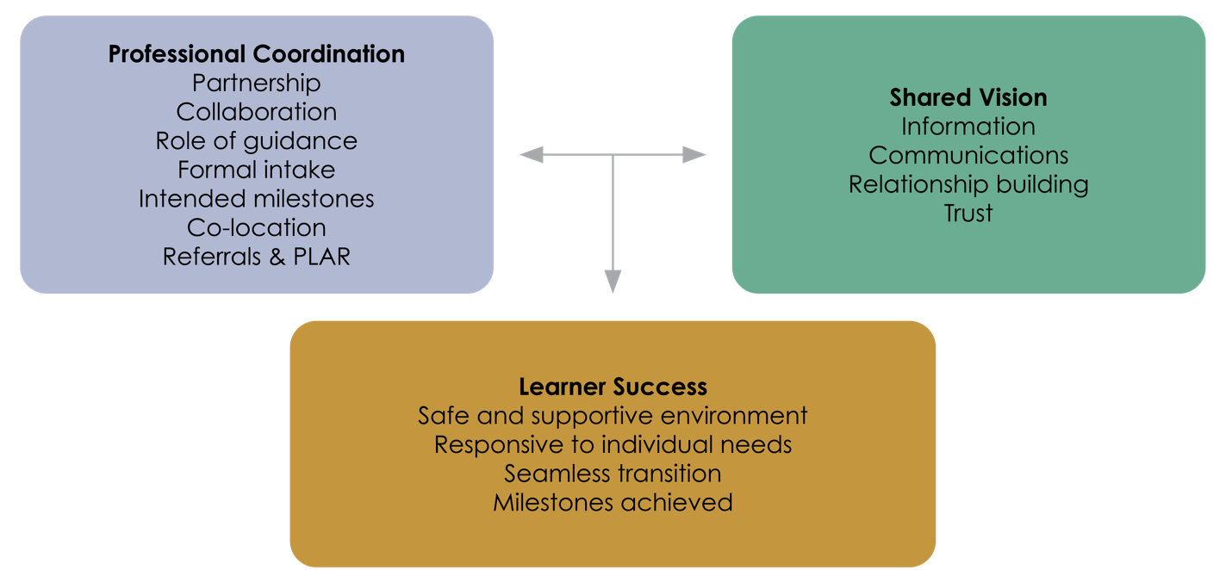
- Godden, L., & Youmans, A. (2023). Literacy and Basic Skills and credit programs scan of Ontario school boards: Final Report. CESBA. https://cesba.com/resources/ontario-lbs-scan/.

Worthwhile Practices for Partnerships in LBS and Credit
Based on survey and interview data, notable partnership practices emerged in relation to the three overarching themes of professional coordination, shared vision, and learner success. Ultimately, strong partnerships marked by effective professional coordination and shared vision contributed to learner success.

WHO WE SERVE

STATISTICS
[INSERT INFORMATION ABOUT YOUR DATA]

STATISTICS
[INSERT INFORMATION ABOUT YOUR DATA]

STATISTICS
[INSERT INFORMATION ABOUT YOUR DATA]

STATISTICS
[INSERT INFORMATION ABOUT YOUR DATA]

STATISTICS
[INSERT INFORMATION ABOUT YOUR DATA]

STATISTICS
[INSERT INFORMATION ABOUT YOUR DATA]

STATISTICS
[INSERT INFORMATION ABOUT YOUR DATA]

STATISTICS
[INSERT INFORMATION ABOUT YOUR DATA]

STATISTICS
[INSERT INFORMATION ABOUT YOUR DATA]

STATISTICS
[INSERT INFORMATION ABOUT YOUR DATA]

- Godden, L., & Youmans, A. (2023). Literacy and Basic Skills and credit programs scan of Ontario school boards: Final Report. CESBA. https://cesba.com/resources/ontario-lbs-scan/.
- Lifelong Learning Advisory Committee. (2018). An overview of the adult education system. https://cesba.com/wp-content/uploads/2020/10/Overview-of-the-Adult-Education-System-English.pdf.
- Statistics Canada. (2013). Skills in Canada: First results from the programme for the international assessment of adult competencies. https://www150.statcan.gc.ca/n1/pub/89-555-x/89-555-x2013001-eng.pdf.
1 in 6
people cannot pass a basic literacy test³
Approximately
45,000
learners participate in LBS programs in Ontario annually²
LBS is offered in
47%
of Ontario School Boards¹

TRENDS IN OUR DATA

[INSERT SUBHEADING]
[INSERT DESCRIPTION OF TRENDS HERE]

AREA OF FOCUS FOR THE 20__ / 20__ FISCAL YEAR

[INSERT SUBHEADING]
[INSERT BULLETS OR PARAGRAPHS]
- [EXAMPLE BULLET]

